**OsteoSense – A Right Step OÜ Experiment**

**ESA 8th Parabolic Flight Campaign**

**Assessing exercise on bone loading from a novel perspective on earth and in microgravity**

In collaboration with;

|  |  |
| --- | --- |
| Tallinn University Of Technology | Jeff Tuhtan |
| University of West London | Dr Jin Luo |
| Université Jean Monnet | Dr Laurence Vico |

Supported by:

|  |  |
| --- | --- |
| ESA BIC Estonia | Sven Lilla |
| European Space Agency | ESA Life Science |
| Novespace | Tihbault Paris |

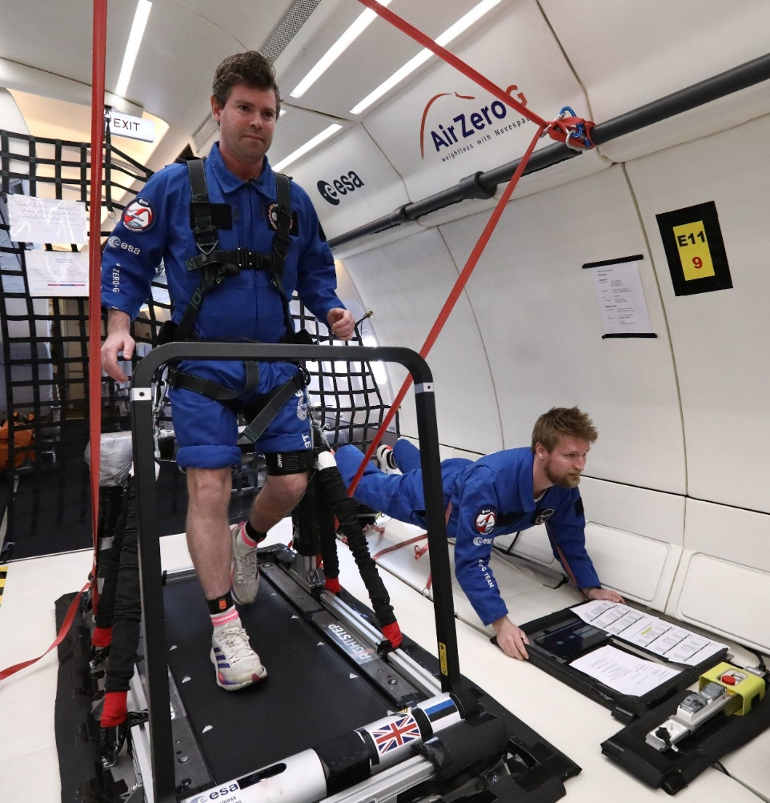

Contents

Project Resources 5

Parabolic Flight Overview 5

What is parabolic flight? 5

Parabola Timings 5

Flight procedure 6

Hypotheses 6

Original Scientific Hypotheses 6

Original Technical Hypotheses 6

Alterations 7

Objectives 7

Scientific objectives 7

Technical Objectives 7

Scientific Background 8

Additions Since Submission 8

Author Additions 9

System Design 10

Treadmill Primary Structure 10

Hyper G Seat 11

Structure Protection 11

Plane Fixation 11

Cabin Layout 12

Final Treadmill System 12

Harness and Bungee System 12

Treadmill and Bungee System 13

Tablet Application 14

Sensors 14

Movella Dot 14

TalTech Sensor 14

Methods 15

System Preparation 15

Measured Weights 15

Procedures 16

Pre Parabola 0 Procedure 16

Post Parabola 30 Procedure 16

Parabola Protocol 16

Experimenter procedures 18

Operator Procedures 18

Activities Performed 19

Baseline data 19

Initial Experiment Observations 19

Aircraft Suspension 19

Bungee System Properties 19

Effect on the Experiment 19

Data Analysis Methods 20

Analysis of loading rate in frequency domain 20

Standard Algorithm Usage 21

Movella Dot Data Analysis 21

Data Preparation 21

Initial Exploration 21

Dataset Creation 22

Visual Data Validation 22

Analysis of Walking 22

Walking Results 23

Walking Frequency Response 24

Walking Discussion 25

Analysis of Running 26

Running Results 26

Running Frequency Response 27

Running Discussion 28

Analysis of Jumping 29

Jumping Frequency Response 30

Jumping Frequency Response of Vertical Axis 31

Discussion 32

Conclusion 33

# Abstract

The experiment explores loading intensity induced, computed via the frequency domain, in a variety of exercises, wearing shoes and barefoot. A protocol consisting of walking, running and micro jumping was carried out on the ground and during 2 parabolic flights consisting of 30 parabolas per flight. Loading intensity, loading balance, total power and the frequency response of activities were analysed. A dedicated treadmill, harness and bungee system was developed along with a dedicated data acquisition and processing application. The experiment produced a set of indicators that support future research endeavours and a software system suitable for use in operational settings where assessment and monitoring of astronaut skeletal load is required. The experiment concluded that;

* Quantifying skeletal loading can be achieved in near real time, in zero g environments with low cognitive load
* Consistent external load delivery is required
* Minimal footwear can induce higher skeletal loading
* High frequencies are absent or significantly diminished in zero g
* Technique adaptations in zero g and due to footwear have an impact on skeletal loading
* Personalisation of assessments and monitoring of skeletal loading is required to optimise health and reduce risk of injury.
* The frequency domain offers a unique and novel insight into exercise performed in zero g.

# Project Resources

|  |  |
| --- | --- |
| Github | [GitHub Repo](https://github.com/mcrooks83/ESA_85th_pbf_campaign_os) |
| Data Set Creation | [Data Set Creation Notebook](https://github.com/mcrooks83/ESA_85th_pbf_campaign_os/blob/main/data_preparation/2.%20data%20cleaning.ipynb) |
| Visual Data Validation | [Data Validation Notebook](https://github.com/mcrooks83/ESA_85th_pbf_campaign_os/blob/main/data_preparation/3.%20data%20validation.ipynb) |
| Walking Analysis | [Walking Analysis Notebook](https://github.com/mcrooks83/ESA_85th_pbf_campaign_os/blob/main/data_processing/1.%20dot%20walk.ipynb) |
| Running Analysis | [Running Analysis Notebook](https://github.com/mcrooks83/ESA_85th_pbf_campaign_os/blob/main/data_processing/2.%20dot%20run.ipynb) |
| Jumping Analysis | [Jumping Analysis Notebook](https://github.com/mcrooks83/ESA_85th_pbf_campaign_os/blob/main/data_processing/3.%20dot%20jump.ipynb) |

# Parabolic Flight Overview

## What is parabolic flight?

Parabolic Flight is a trajectory taken by an aircraft that reproduces various levels of gravity, in particular hyper g (1.8g) and zero g (microgravity). It is achieved by flying the aircraft in upward and downward arcs that are interspersed with level flight. A parabolic flight creates environments for researchers to conduct experiments without needing to go to space. They provide an environment for the “normal” person to experience what an astronaut experiences in space and thus be able to design appropriate experiments for the environment. Weightlessness is achieved for approximately 22 seconds with 20 seconds of hyper gravity on either side of the parabola. The aircraft pulls up, initially reaching around 50 degrees of nose up before “injection” which guides the plane over the top of the parabola. This is achieved by reducing the engine speed allowing the aircraft to follow a ballistic trajectory, essentially free fall. The parabola peak is exited at approximately 42 degrees nose down and 20 seconds later pulls out to level flight. The aircraft travels at a speed of 810 km/h at an altitude of 6000m before the manoeuvre is carried out.

## Parabola Timings

## Flight procedure

A typical flight consists of 30 parabolas executed in blocks of 5 or 6. During a campaign 3 flights are flown. A diagram of the flight profile is shown below.

# Hypotheses

The following hypotheses are taken directly from the original proposal submitted to SciSpace CORA.

## Original Scientific Hypotheses

The scientific hypotheses are considered to provide a foundation to further research in space.

* There is a difference in loading intensity and frequency content of signals generated on the ground vs microgravity in parabolic flight
* Exercise performed in footwear vs barefoot elicit an increase in loading intensity both on the ground and in parabolic flight
* Generated frequency response in microgravity can be replicated on the ground and vice versa

## Original Technical Hypotheses

The technical hypotheses aim to address the need to measure and monitor musculoskeletal loading.

* The proposed technology can measure and monitor loading parameters in real time and in a micro gravity environment
* The proposed technology can capture required accelerometery data over the duration of a parabolic flight (3-4 hours)
* Activities performed with and without footwear result in observable loading profile alterations

## Alterations

The first two scientific hypotheses were considered to be biomedical in nature and imposed ethical approval. These were removed as time would not allow approval to be obtained. It was deemed that the experiment would only provide an indication rather than a true scientific outcome since there are only two subjects. Given that the required data would be collected anyway to explore these hypotheses the analysis can still be conducted.

The second technical hypothesis was removed completely as it would involve a third sensor type. This was deemed impractical and was replaced in favour of the newly developed high data rate sensor that could provide more insight into the aspects of skeletal loading.

# Objectives

## Scientific objectives

The scientific objectives aim to provide a new insight and perspective into the quantification of skeletal loading and will form the foundation of future research.

1. What is the measurable difference between activities performed on the ground vs microgravity?
2. What are the measurable differences in the frequency response of the test battery on the ground vs microgravity?
3. What activities induced greater loading potential for bone adaptation?
4. Do certain activities in the battery produce similar loading potential when performed on earth and in microgravity?

## Technical Objectives

The technical objectives assess the feasibility for real time measurement and monitoring of musculoskeletal loading in micro gravity as a prerequisite for leveraging such a solution on the International Space Station.

* Ability of the technology to capture and process “skeletal loading” metrics in near real time
* Ability to effectively use the solution in a micro gravity environment
* Ability to use such a solution on the ISS

# Scientific Background

Bone loss in astronauts is a well documented challenge and there are currently no accepted solutions to improving astronauts’ preparation, maintenance and recovery.  The recent paper "Musculoskeletal research in human space flight – unmet needs for the success of crewed deep space exploration" (4) highlights the importance of understanding the loads acting on the musculoskeletal system during a mission.  It also suggests that research should be conducted not only in flight but also pre and post making a strong reference to the "forgotten period" of post flight.  **The simple message is that exercise countermeasures have been studied extensively, but the optimal program has yet to be found.**

Therefore, the aim is to improve the prevention and treatment of bone de-conditioning in astronauts on long-duration flights. It is assumed that if the level of physical activity during a space mission is much lower than before the mission, bone loss could be greater (2). We know that recovery time after a flight lasting several months is very long and even uncertain (9). The aim is to monitor astronauts before/during/after flight in order to re-establish the right levels of exercise when necessary.

Previous research has developed a novel method that can objectively assess mechanical loading of physical activity using acceleration data recorded in daily life (3). This method is underpinned by previous experimental findings on bone adaptation to mechanical loading (7,8) . Using this method it was found that loading dose of moderate-to-vigorous activities was associated with bone density at the calcaneus bone in middle-aged men and women (1,6). Furthermore, by analysing data from 3,000 participants from UK Biobank, it was also found that loading dose of moderate-to-vigorous physical activity was positively associated with bone mineral density (BMD) and bone mineral content (BMC) at lumbar spine and femur in a cohort of middle-aged and elderly UK adults (5), suggesting that there is a dose-response relationship between mechanical loading of physical activity and bone health in the human body.

Bone adaptation to mechanical loading is dependent on three parameters, namely, magnitude, frequency and duration. The analysis method considers all three of these by sensing the accelerative magnitude in the three planes of motion and the frequency response in a pre-defined time window. This means that musculoskeletal loading and thus bone adaptation may favour high frequency signals. However, effective loading responses could also be elicited it at low frequency coupled with higher acceleration. In addition, the duration component may be misleading in that bone adaption saturates as osteocytes become less effective at sensing continuous load. Whilst there is no means to measure bone biomarkers or take bone images in the parabolic flight analogue this would be useful in further research efforts should this stage be successful.

## Additions Since Submission

The musculoskeletal system is essential for the maintenance of physical health during exploration missions, and consequently mission success. The known effects of reduced gravitational forces and mechanical loads on bone and muscle comprise overall loss of mass, resulting in site-dependent deterioration of bone integrity and bone strength. ESA’s SciSpace White Paper 12: Human Physiology outlines the need to quantify the musculoskeletal load during space flights to investigate interindividual variability comprising of appropriate biomarkers, individualisation of countermeasures and an ability to anticipate dangerous alterations to the musculoskeletal system. The ESA Explore2040 strategy explicitly prioritises support for these claims. Exploration-enabled and exploration-focussed research activities will be underpinned by the technologies required to realise these activities along with the potential to address global challenges in health and wellness.

This therefore demands an ability to quantify musculoskeletal loading to meet the need to measure and monitor individual changes, profile exercise-based counter measures and provide individualisation in near real time.

Biomechanical parameters are often used as biomarkers to quantify musculoskeletal load. Among them, loading rate is an important biomarker that measures how fast a load changes with time. Previous research found that loading rate was directly linked to biological responses of musculoskeletal tissues. Animal experiments showed that bone formation rate was proportional to strain rate of dynamic loading (Turner et al., 1995), while observational studies on human indicated that higher loading rate was associated with tibia stress fracture (Milner et al., 2006) and knee osteoarthritis (Mundermann et al., 2005).

To date, loading rate is mainly assessed in time domain based on the measurement of ground reaction force. However, time domain analysis may not provide comprehensive information as the biological effect of loading rate varies at different frequency ranges. For example, the relationship between applied strain rate and osteogenic response of cortical bone changes over a frequency range between 1 and 10 Hz (Hsieh and Turner, 2001) . Damage of articular cartilage induced by compressive load increases with frequency from 1 Hz to 100 Hz (Sadeghi et al., 2015). These findings suggest that the analysis of loading rate in frequency domain may be able to provide more insight into the effect of load on musculoskeletal system.

## Author Additions

It may be suggested that the problem facing astronauts is a reverse problem to here on earth. On earth there are challenges with over loading of muscles and bones resulting in injury. The running shoe industry has made a conscience effort to reduce shock, essentially absorbing the mechanical loading experienced by the human body. In space this loading is required due to the lack of gravity yet astronauts exercise with the same type of footwear used on earth. This observation suggests that either the systems used in space are the equivalent of earth or that there may have been an oversight.

During anecdotal conversations it was been articulated that the systems on the International Space Station are not adequate for astronaut exercise due to reported discomfort, accuracy in providing the appropriate forces to simulate earth (65-75% body weight) and that future iterations of the space station will be further constrained in terms of available space in which to exercise.

Given that moderate to vigorous activity is a prerequisite for bone adaptation and thus the maintenance of the skeletal system there is a definitive need to be able to perform such activities whilst on space missions whether this be in the space station or subsequently on the moon or mars.

There must be an agreed way to quantify skeletal loading that has some correlation with bone processes and then a range activities must be profiled for appropriateness and effect. Physiological responses are likely to be individual and thus exercise programs must be adapted to suit. There is a parallel need to consider the exercise equipment and its ability to deliver the desired outcome as if not, the comparison of activity cannot be accurately achieved.

Other impact related exercise has been reported as promising such as single leg hopping that on earth are considered a plyometric exercise. This makes logical sense but there are practical considerations as to the delivery of such exercises onboard the space station.

In the capture of human movement sensors are used with a data rate of up to 100Hz (60Hz in the case of Movella Dot) and then subsequently filtered to below 10Hz. This captures the movement of a limb or body segment as a whole and is used to analyse the actual movement of the body in question. Since skeletal loading is previously defined is a combination of magnitude and frequency the signals generated by impacts could be viewed as vibrations. Bones are active structures, but at lower data rates the analysis may only consider its movement rather than the signals that it is experiencing. Therefore, it may be useful to consider the underlying structure as a material that undergoes vibration, similar to perhaps a bridge. To explore this a much higher data rate is required and hence a specific sensor has been developed for this purpose.

# System Design

## Treadmill Primary Structure

Figure 1: Basic Treadmill CAD

The primary structure consisted of a commercially available treadmill (Kingsmith MC2v) secured to an aluminium (EN-AW-5083) base plate. The base plate has a tensile strength of 317 MPa to comply with the requirements set out by Novespace.

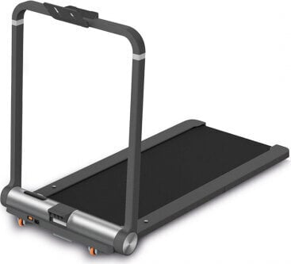

Figure 2: MCv2 Treadmill

The treadmill’s 8 feet were removed to allow the centre 4 to be directly secured to the baseplate via M10 counter sunk screws. The other 4 feet holes located at each end of the treadmill were also secured via M10 counter sunk screws but were bolted from the top. All counter sunk screws that attached the treadmill were inserted from the underside of the base plate, were torqued to 25Nm with Loctite applied.

Surrounding the treadmill on all sides were Bosch Rexroth profiles secured to the baseplate via companion brackets. At the end where the power supply resides the profiles were cut to allow access and the power cable and secured via an adhesive cable support and cable tie.

Secured to along the length of the baseplate were 4 anchor rings that allowed a bungee system to be clipped in. 4 additional rings, 2 at each end of the plate were placed to allow for easier lifting of the structure. All bolts were torqued to 25Nm with Loctite applied.

## Hyper G Seat

A seat was constructed from Bosch Profiles and positioned to allow the experimenter to be comfortably seated during hyper gravity phases of flight. This requirement is due to the experimenter experiencing close to 2x body weight with the addition of the bungee system.

## Structure Protection

Sharp corners and edges including the seat and the baseplate were covered with an appropriate grade of foam. The treadmills safety cord is required for operation and safety of the experimenter and was thus attached to the experimenter’s harness during flight.

## Aircraft Fixation

The base plate comprises of 4 fixation holes that allow the plate to be securely attached to the seat track of the plane. Two additional spacers were placed along the seat tracks at the midpoint of the base plate to prevent bending of the plate whilst performing activities on the treadmill.

## Cabin Layout

## Final Treadmill System

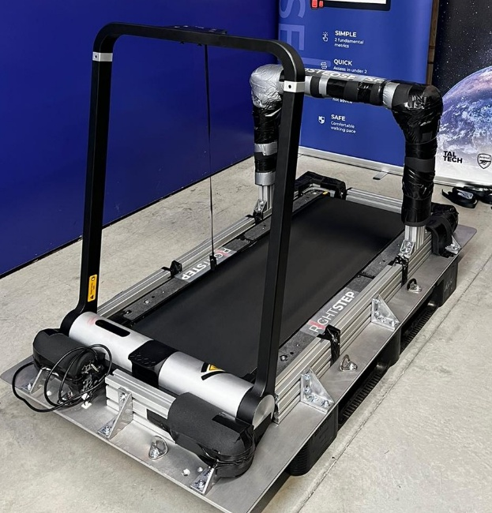

Figure 3: Treadmill On Ground Figure 4: Treadmill On the Aircraft

## Harness and Bungee System

In Zero G or micro gravity there is weightlessness meaning that the experimenter would be unable to perform activities on the treadmill without the assistance of a tethering system. To enable the experimenter to perform activities a bungee system was devised consisting of a harness, 2 bungee ropes clipped either side of the experimenter and a set of carabiners to allow the system to be adjusted according to the experimenter.

The harness was a COVERGUARD ALIOTH Full Body Harness with Positioning Belt that has a breaking strength of >15kN, a user capacity of 140Kg and a weight of 2.3 kg. It has 2 rings positioned at the hip to allow the bungee system to be clipped in. Crucially, the chosen harness is very well padded to provide optimal comfort to the experimenter.

The bungee cords were sourced from an Arial Yoga provider and are used primarily to anchor a yoga participant from the ceiling. A medium strength yoga bungee was selected to accommodate the weight of the experimenters.

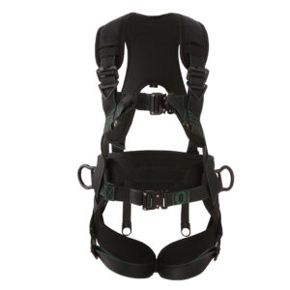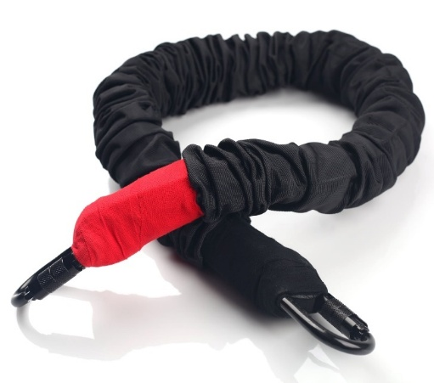

*Figure 5: Harness and Bungee System*

## Tablet Application

A tablet application was developed to streamline the process of data acquisition and to reduce the cognitive load required to execute the experiment.

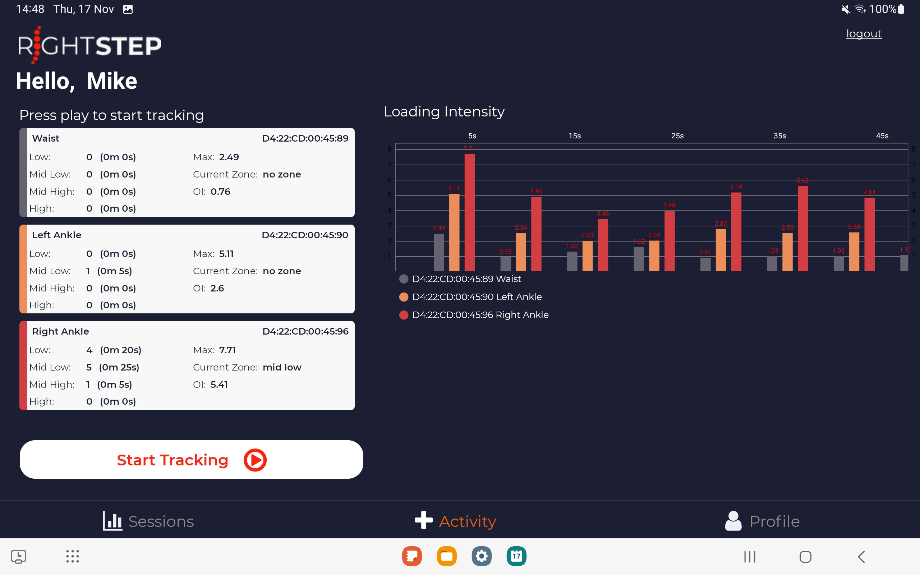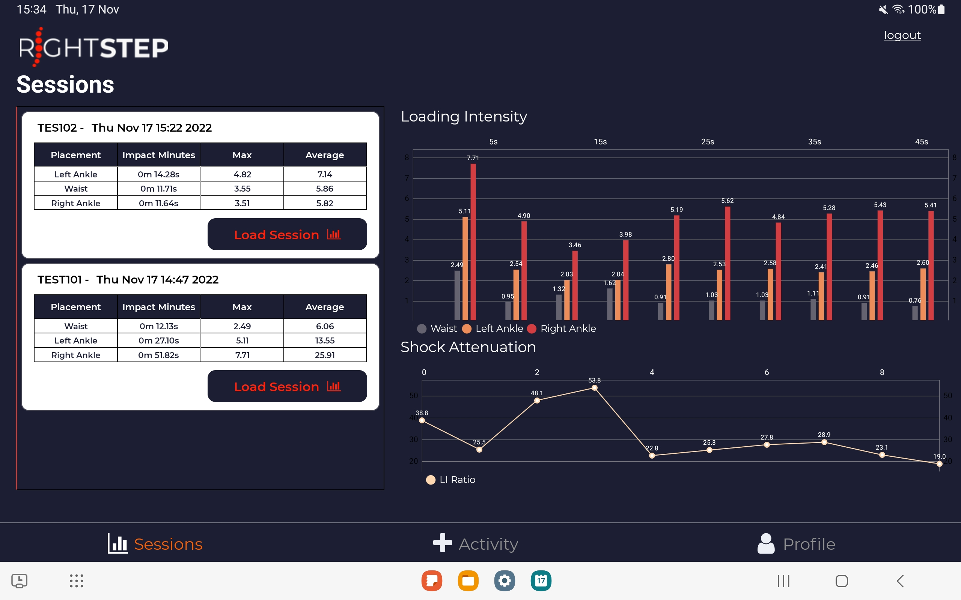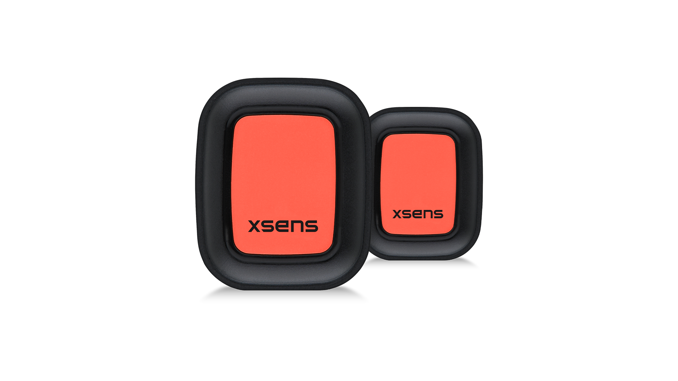

*Figure 6: Tablet Application (note: updates were made)*

The application is designed to manage the Movella Dot sensors that were worn on each limb at the ankle. The application consists of 3 sub parts that allow setup of the sensor, data acquisition, near real time processing and uploading of raw data files.

Sensors are discovered via a low energy Bluetooth scan and connected to by pressing the toggle button. A button on the sensor itself allows the sensor to be assigned to a limb. The experimenters were pre-loaded into the application at build time, and one is appropriately selected.

The start measurement button is pressed which brings up a dialog box to enter a tag for the activity (see parabola protocol for codes). The start button present in the dialog box initiates the sensor data stream. The activity is stopped via the stop button.

On completion of an activity the data is stored to the device and an upload button is available to upload the data post flight. This is required as there is no connectivity during flight. On upload data is stored in blob storage in Azure and available for download.

## Sensors

There were two sensor types used in the experiment. Two Movella Dots worn at the ankle of each limb and a custom sensor developed in collaboration with TalTech.

### Movella Dot

*Figure 7: Movella Dots*

The Movella Dot has a data rate of 60Hz and a low energy Bluetooth interface. Dedicated sensor holders and straps are provided.

### TalTech Sensor

The Taltech Sensor is an accelerometer that has a data rate of 6.6Khz. The accelerometer is on a short wire and is fixed directly to the tibia via medical tape. The sensor is controlled by a dedicated control box that is strapped to the thigh. The sensor is turned on and off via a switch located on the control box and is powered by 2 standard AAA batteries.

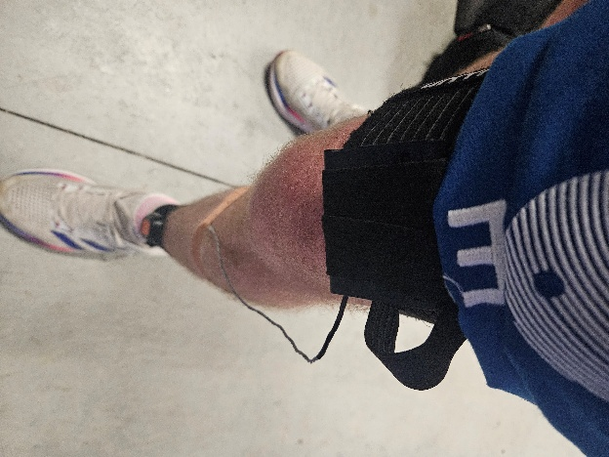

Figure 8: Taltech Sensor

# Methods

## System Preparation

Prior to each flight the experimenter was weighed on the treadmill whilst wearing the harness. The bungee cords were attached, and the experimenter was weighed again. The aim was to achieve 2x body weight when wearing the harness. For example, if the experimenter weighed 82kg with the harness on then the scales should read ~164kg with the bungees attached. Due to the flexible nature of a bungee the experimenter was asked to push onto tip toes to obtain a range of values.

### Measured Weights

|  |  |  |  |
| --- | --- | --- | --- |
| **Experimenter** | **Static Weight with harness (kg)** | **Static Weight with bungee system (kg)** | **Tiptoe weight with bungee system (kg)** |
| 1 | 85.5 | 152.9 | 172 |
| 2 | 82.9 | 176.7 | > 180kg |

The bungee system can be adjusted by adding or removing carabiners. Both experimenters weighed roughly the same but differed in height by a few centimetres. Therefore, the settled upon configuration consisted of the main carabiner plus 2.5 carabiners for experimenter 1 and plus 1.5 carabiners for experimenter 2. This configuration resulted in the closest measurements to 2x body weight. Note that the measurements suggest that experimenter 1 could be underloaded and experimenter 2 overloaded.

With this step complete the experiment equipment was double checked and sensors attached to the experimenter.

## Procedures

### Pre Parabola 0 Procedure

Prior to the first parabola (parabola 0) there was 10-20 minutes to setup the experiment. The following procedure was followed.

|  |
| --- |
| Fix sensors in place. (actually done pre flight) |
| Remove long straps securing the treadmill and place in main pocket of bag |
| Remove short straps securing the treadmill and place in front pocket of bag |
| Attach bungees to the primary structure and clip to safety straps |
| Turn on power (Red / red / red) |
| Turn on treadmill power |
| Turn on camera |
| Turn on Tablet |
| Get into position for parabola 0 |
| Turn on and setup Movella Dot sensors (including assignment) |

### Post Parabola 30 Procedure

With the parabola’s complete the following procedure was followed to secure the experiment and prepare for landing.

|  |
| --- |
| Disconnect sensors from tablet |
| Turn off tablet |
| Turn off sensors |
| Turn off treadmill |
| Turn of camera |
| Turn off aircraft power supply |
| Remove bungees and place in bag |
| Secure treadmill with short straps |
| Secure treadmill with long straps |

### Parabola Protocol

A parabolic flight is segmented into blocks of 5/6 parabolas with a level flight break in between. The protocol is designed for ease of execution giving appropriate time for adjustment to the environment. Appropriate contingency parabolas were built into the protocol to allow for errors and difficulties.

Flight 1 and Flight 2 reversed the operator and experimenter to obtain two data sets. Flight 3 was left as a complete contingency flight.

**Block 1**

|  |  |  |  |
| --- | --- | --- | --- |
| **Parabola** | **Code** | **Activity** | **Footwear** |
| **0** |  | **Sit** | **Shoes** |
| **1** |  | **Practice** | **Shoes** |
| **2** | **SW2** | **Walk – speed 5** | **Shoes** |
| **3** | **SW3** | **Walk – speed 5** | **Shoes** |
| **4** | **SW4** | **Walk – speed 5** | **Shoes** |
| **5** | **SW5** | **Walk – speed 5** | **Shoes** |

**5 Min break**

**Block 2**

|  |  |  |  |
| --- | --- | --- | --- |
| **Parabola** | **Code** | **Activity** | **Footwear** |
| **6** | **SR6** | **Run – Speed 8** | **Shoes** |
| **7** | **SR7** | **Run – Speed 8** | **Shoes** |
| **8** | **SR8** | **Run – Speed 8** | **Shoes** |
| **9** | **SR9** | **Run – Speed 8** | **Shoes** |
| **10** | **SJ10** | **Jump – speed 0** | **Shoes** |

**5 Min break**

**Block 3**

|  |  |  |  |
| --- | --- | --- | --- |
| **Parabola** | **Code** | **Activity** | **Footwear** |
| **11** | **SJ11** | **Jump – speed 0** | **Shoes** |
| **12** | **SJ12** | **Jump – speed 0** | **Shoes** |
| **13** | **??13** | **Contingency / walk** | **Shoes** |
| **14** | **??14** | **Contingency / walk** | **Shoes** |
| **15** | **??15** | **Contingency / walk** | **Shoes** |

**8 Minute Break - REMOVE SHOES**

**Block 4**

|  |  |  |  |
| --- | --- | --- | --- |
| **Parabola** | **Code** | **Activity** | **Footwear** |
| **16** | **BW16** | **Walk – speed 5** | **Barefoot** |
| **17** | **BW17** | **Walk – speed 5** | **Barefoot** |
| **18** | **BW18** | **Walk – speed 5** | **Barefoot** |
| **19** | **BW19** | **Walk – speed 5** | **Barefoot** |
| **20** | **BR20** | **Run – speed 8** | **Barefoot** |

**5 Min break**

**Block 5**

|  |  |  |  |
| --- | --- | --- | --- |
| **Parabola** | **Code** | **Activity** | **Footwear** |
| **21** | **BR21** | **Run – speed 8** | **Barefoot** |
| **22** | **BR22** | **Run – speed 8** | **Barefoot** |
| **23** | **BR23** | **Run – speed 8** | **Barefoot** |
| **24** | **BJ24** | **Jump – speed 0** | **Barefoot** |
| **25** | **BJ25** | **Jump – speed 0** | **Barefoot** |

**5 Min break**

**Block 6**

|  |  |  |  |
| --- | --- | --- | --- |
| **Parabola** | **Code** | **Activity** | **Footwear** |
| **26** | **BJ26** | **Jump – speed 0** | **Barefoot** |
| **27** | **??27** | **Contingency / walk** | **Barefoot** |
| **28** | **??28** | **Contingency / walk** | **Barefoot** |
| **29** | **??29** | **Contingency / walk** | **Barefoot** |
| **30** | **??20** | **Contingency / walk** | **Barefoot** |

### Experimenter procedures

The experimenter performs the activities. The following procedure was practiced repeatedly and followed during flight. Parabola 0 is not experimented in, parabola 1 is used to acclimate and 2-30 are experiment parabolas.

|  |  |  |
| --- | --- | --- |
| **Parabola** | **Phase** | **Task** |
| 0 | - | - |
| 1 | Level Flight | Get on treadmill  Attach bungees  Attach safety cord |
|  | Injection | Practice sitting / standing  Flex bungees  Assess bungee pull in zero g |
|  | 20 | Sit down |
|  | Level Flight | Set treadmill to speed  Assign sensors if not done |
| 2-30 | Level Flight | Confirm Next protocol  Adjust treadmill if required |
|  | 40 | Turn on Taltech sensor |
|  | Injection | Perform activity |
|  | 20 / 30 | Sit down  Turn off taltech sensor |

### Operator Procedures

The operator is the role managing the protocol and data collection. The following procedure was practiced repeatedly and followed during flight. Parabola 0 is not experimented in, parabola 1 is used to acclimate and 2-30 are experiment parabolas.

|  |  |  |
| --- | --- | --- |
| **Parabola** | **Phase** | **Task** |
| 0 | - | - |
| 1 | Level Flight | Assist attaching bungees |
|  | Injection | - |
|  | 20 | - |
|  | Level Flight | Assign sensors if not done |
| 2-30 | Level Flight | Confirm application setup:   * Correct experiment assigned * Sensors connected * Right and left assigned   Go to measure tab   * Select start measuring * Confirm next protocol * Type in parabola code |
|  | 40 | Press START |
|  | Injection | Perform activity |
|  | 20 / 30 | Press stop measuring when experimenter is sitting |

### Activities Performed

The experiment consists of walking at 5 km/h, running at 8 km/h and micro jumping in place. These activities are performed with and without shoes. The speeds were selected primarily for safety reasons due to the team being first time flyers.

It should be noted that adaptation to the environment was quick and that it was possible to run at 10 km/h. This was done and some additional data collected, however, is not used in the analysis as it was not part of the original experiment design.

Additionally, it was suggested that the treadmill may run faster in zero g due to a lower constant of friction.

### Baseline data

Baseline data was collected for each experimenter on the Friday of preparation week. The complete structure had been installed in the aircraft and the protocol was followed for each parabola disregarding contingencies.

## Initial Experiment Observations

### Aircraft Suspension

During the baseline data collection, it was observed that the aircraft was subjected to oscillations that could be felt further down the aircraft by other experimenters. This was an initial concern, but it was reasoned that this may be due to the aircraft being on the ground and be due to its suspension. There is suggestion that this may also act as load dampener resulting in lower experience skeletal loading of the experimenter. This oscillation was not present in flight the aircraft may be more rigid and thus induce a higher skeletal loading in zero g than expected.

### Bungee System Properties

It was observed in preflight preparation that the bungee cords were stiffer, perhaps due to being stored in the aircraft overnight and being exposed to low temperatures. Stretching the bungee cords whilst on the ground seemed to loosen them up and provide lower values when the experimenter was weighed. It was also felt that the bungee cords tension reduced over time and thus later parabolas may induce less load.

In the first walking parabolas of flight 2 the experimenter reported feeling overloaded suggesting that the bungee cords were exerting a value greater than 2x body weight which is in step with the overloaded measurement on the scales when weighed. This reduced over time (or the experimenter became accustomed to the pull).

Experimenter 1 was initially underloaded according to the weight measurements and reported “easy” movement throughout the flight.

### Effect on the Experiment

It is possible that the bungee system could influence the results. The activities where the experimenter wore shoes were performed in the first half of the flight and thus the load induced in the latter half of the flight may be lower regardless of the removal of shoes.

The possible dampening by the aircraft on ground may influence the loading achieved which may result in similar or higher loading being achieved in zero g.

The bungee system is affected by height and no adjustments were made when shoes were removed. This could lead to a lower tension in the bungee being applied when shoes are removed which would lead to lower than anticipated loading.

Additionally, the treadmill has a shock absorption system built into it which may reduce the available frequency signals reaching the body.

# Data Analysis Methods

## Analysis of loading rate in frequency domain

A time-domain load signal $F\left(t\right)$ satisfying Dirichlet conditions can be expressed by discrete Fourier transformation as the sum of a finite number of sine and cosine components:

$$F\left(t\right)= a_{0}+\sum_{n=1}^{N/2}{{(a}_{n}\cos\left(nωt\right)+b_{n}\sin{(nωt)) (1)}}$$

where $N$ is the total number of points for $F\left(t\right)$, $n$ represents the *nth* harmonic; $a_{n}$ and $b_{n}$ are harmonic coefficients, $ω$ represents the fundamental frequency of the signal, and $t$ is the time. The magnitude of each harmonic for $F\left(t\right)$ is defined as

$M_{n}=\sqrt{a_{n}^{2}+b_{n}^{2}}$ (2)

The rate of change of the load signal $F\left(t\right)$ can be obtained by differentiation of equation (1) with respect to $t$,

$$\dot{F}(t)= \sum_{n=1}^{N/2}{{(-nωa}_{n}\sin{(nωt)}{+{nωb}_{n}\cos{(nωt}{)) (3)}}}$$

where $\dot{F}(t)$ represents the rate of change. The magnitude of each harmonic for $\dot{F}(t)$ can be expressed as

${DM}_{n}=nω\sqrt{a_{n}^{2}+b_{n}^{2}}=nωM_{n}$ (4)

where ${DM}_{n}$ is the magnitude of *nth* harmonic of $\dot{F}(t)$, which equals the magnitude ${(M}_{n})$ of the harmonic of $F\left(t\right)$ multiplied by its frequency $(nω)$. This provides a way to analyse loading rate over a particular frequency range, as represented by the following equation.

$$LI=\sum_{n=i}^{j}{A_{n}×f_{n}} (5)$$

where $LI$ (*BW/s*) is termed loading intensity that represents the loading rate over a frequency range from *ith* to *jth* harmonics, $A_{n}$ is the acceleration (*g*) at the *nth* harmonic, and $f_{n}$ is the *nth* harmonic frequency (*Hz*).

## Standard Algorithm Usage

Typically, equation 5 is implemented by capturing a 5 second window of data and bandpass filtering the data between 0.1 and 6Hz. This is to remove effects of gravity and low frequency noise and remove muscle and skin artifacts. 5 seconds is used to ensure that at least one complete movement cycle is captured and provides enough data for the Fast Fourier Transform to be computed with sufficient resolution.

Using the Movella Dot the time window equates to 300 samples at 60Hz. The Taltech sensor has a data rate of 6 KHz and thus 30,000 samples are captured per 5 second window. This may result in a more accurate result yet imposes challenges in data streaming, data capture size and processing times. Therefore the Taltech sensor was developed as a data logger and not directly implemented into the tablet application. The primary purpose of the Taltech sensor in this experiment is to observe the frequency response over a greater range (up to 3kHz) compared to 30Hz that can be observed by a 60Hz sensor.

# Movella Dot Data Analysis

## Data Preparation

Collected data was placed in a consistent directory hierarchy.

*../data/raw_data/<environment>/<experimenter>/<sensor>/<footwear>/<parabola_code>*

An example data path for parabola 2, experimenter 1, walk would be

*../data/raw_data/flight/exp1/dot/shoes/sw2*

## Initial Exploration

A single parabola was visualised to observe the data points collected. For a given parabola, sw3, the associated left and right ankle csv file was read in and the x,y,z acceleration extracted. The magnitude vector was computed and subsequently plotted. This was done for a select number of parabolas for each experimenter.

The raw data collected on the ground clearly depicts gravity as 1g where as the raw data collected in zero g does not.

Inconsistencies were observed in the starting and stopping of the tablet application between operators. However, data was collected consistently up to 1400 data samples.

Data capture commences when the 40 announcement is made. When the injection announcement was made the experimenter gets onto the treadmill and begins the activity. The time from 40 to injection is roughly 3 seconds and 2 seconds is allowed for the experimenter to stabilise the activity. Thus, it makes sense to remove the first 5 seconds (300 data samples) to accommodate for this.

As previously stated, loading intensity is typically computed in 5 second windows. Due to the nature of parabolic flight and the time available in zero g the data was trimmed to find a stable 15 seconds of data to work with and then the loading metrics computed for the duration of the activity. This would also correspond to a loading dose experienced as dose requires a duration that the load is applied for, in this case 15 seconds.

Therefore a data set for a given parabola and activity would compromise of the first 900 samples post activity stabilisation (post 5 seconds from starting the data capture).

The bandpass filter was applied to the magnitude vector with 0.1Hz low cut off and 6Hz high cut off. It was observed that there was a low frequency “wave” present in the filtered data. This is suggested to be the trajectory of the aircraft and thus a higher low cut off frequency of 0.5 Hz was applied to remove this.

## Dataset Creation

The objective of this procedure is to obtain data sets that are of the same length and capturing the same portion of time associated to each activity.

The output is a replica of the raw_data directory hierarchy with each data file reduced to 900 samples as outline above.

Data acquisition of Parabola 23 (barefoot run) for experimenter 2 was started late and thus does not conform to the above cleaning procedure. Visualising this data shows that between 1200 and 2100 samples is the equivalent and was used.

## Visual Data Validation

Post data set creation, the datasets were validated by visualising the magnitude acceleration for each trial in baseline and flight. It can be observed that the magnitude acceleration signal differs for each activity.

*Figure 9: Example of Raw Flight Data*

## Analysis of Walking

Data was loaded from the clean directory and excluded trials sw2 and bw16. These are the first walks done in flight with shoes and barefoot. The reason for exclusion was simply to allow the subject a trial to acclimate to the zero g environment.

For each trial there is two data sets, one for the left limb and one for the right limb. Skeletal loading metrics were computed for each limb and stored in the load_outputs dictionary. Following this step the following list of metrics were computed for each limb in flight and for the baseline.

|  |  |
| --- | --- |
| **Metric** | **Definition** |
| Average left load | Average of 3 trials the same (i.e shoes walking) |
| Average right load | As above |
| Average total load | Average of left and right load |
| Average x axis | Average of 3 trials the same, x axis only |
| Average y axis | Average of 3 trials the same, y axis only |
| Average z axis | Average of 3 trials the same, z axis only |

To compute the skeletal loading metrics each trial was loaded as a data frame. This data frame contains Acc_X, Acc_Y and Acc_Z columns. These columns were extracted and converted to arrays and the raw unit of meters per seconds squared converted to g by dividing by 9.80665. The magnitude vector was then computed and subsequently passed through a 5th order bandpass filter with low cut off equal to 0.5 Hz and the high cut off equal to 6 Hz (ref jin). The low cut off of 0.5 Hz in place of 0.1Hz was used to remove low frequencies generated by the trajectory of the aircraft that was observed in the initial data exploration.

The FFT is then computed from the filtered magnitude and the loading intensity computed by summing the acceleration * frequency up to the cut off frequency of 6Hz.

Each axis was then independently passed through the same algorithm to provide the loading contribution for a given axis. The skeletal loading metrics described in the table above were then computed. This was performed for each experimenter.

Additionally, a set of balance metrics were computed. Balance of load measures the loading present in each limb and computes the percentage contribution. This means that even loading in each limb would result in a 50:50 ratio.

#### Frequency Response and Total Power

The last walking trial for shoes and barefoot was chosen as the most representative due to 3 prior trials having been performed. The signals were filtered using the same filter parameters as before followed by computing the FFT of the magnitude acceleration.

The power of the spectrum was computed as the sum of the frequency squared for each shoe and barefoot trial, for both limbs and in both environments. The total power is computed as the sum of the power spectrum.

### Walking Results

In Table 2, experimenter 1 in the baseline environment shows an increase in total loading when barefoot with experimenter 1 showing a greater increase than experimenter 2. In flight experimenter 1 again shows an increase in loading when barefoot although to a lesser extent than baseline. Experimenter 2 shows a much greater loading experienced in flight and a decrease in loading when barefoot.

|  |  |  |  |  |  |  |  |
| --- | --- | --- | --- | --- | --- | --- | --- |
| **Exp** | **Environment** | **Shoes (Total)** | **Shoes (Left)** | **Shoes (Right)** | **Barefoot (Total)** | **Barefoot**  **(Left)** | **Barefoot**  **(Right)** |
| 1 | Baseline | 10.09 | 9.64 | 10.54 | 10.8 | 10.03 | 11.57 |
|  | Flight | 10.34 | 10.14 | 10.54 | 10.74 | 10.54 | 10.95 |
|  |  |  |  |  |  |  |  |
| 2 | Baseline | 9.01 | 8.73 | 9.29 | 10.87 | 10.75 | 10.99 |
|  | Flight | 14.34 | 14.37 | 14.3 | 11.72 | 11.66 | 11.78 |

**Table 2: Loading Metrics (BW/s)**

In table 3, experimenter 1 shows a significant increase in z axis loading contribution in flight. The z axis points through the sensor and is described as the forward-backward direction, anterior-posterior or sagittal plane. The x contribution or vertical motion for experimenter 1 is decreased. Whilst total loading is similar, the axial contribution changes in zero g. Experimenter 2 also demonstrates the increase in z axis loading contribution.

|  |  |  |  |  |  |  |  |
| --- | --- | --- | --- | --- | --- | --- | --- |
| **Exp** | **Environment** | **Left (x)** | **Left (y)** | **Left (z)** | **Right (x)** | **Right (y)** | **Right (z)** |
| 1 | Baseline (shoes) | 10.25 | 7.87 | 9.82 | 10.69 | 6.12 | 11.14 |
|  | Baseline (barefoot) | 10.36 | 7.58 | 9.89 | 11.46 | 7.65 | 10.54 |
|  | Flight (shoes) | 7.68 | 6.64 | 13.9 | 6.73 | 7.06 | 14.01 |
|  | Flight (barefoot) | 7.43 | 7.97 | 14.49 | 7.16 | 7.79 | 14.18 |
|  |  |  |  |  |  |  |  |
| 2 | Baseline (shoes) | 8.81 | 3.87 | 11.05 | 9.57 | 4.4 | 12.31 |
|  | Baseline (barefoot) | 9.78 | 4.04 | 13.6 | 9.49 | 5.09 | 12.17 |
|  | Flight (shoes) | 9.69 | 4.89 | 16.45 | 9.43 | 6.47 | 16.53 |
|  | Flight (barefoot) | 8.27 | 4.94 | 16.45 | 7.78 | 6.16 | 14.06 |

**Table 3: Axial Loading Metrics (BW/s)**

In Table 4, the asymmetry improves for both experimenters when in flight.

|  |  |  |  |
| --- | --- | --- | --- |
| **Exp** | **Environment** | **% in Left** | **% in Right** |
| 1 | Baseline (shoes) | 47.77 | 52.23 |
|  | Baseline (barefoot) | 46.44 | 53.56 |
|  | Flight (shoes) | 49.03 | 50.97 |
|  | Flight (barefoot) | 49.05 | 50.95 |
|  |  |  |  |
| 2 | Baseline (shoes) | 48.45 | 51.55 |
|  | Baseline (barefoot) | 49.45 | 50.55 |
|  | Flight (shoes) | 50.12 | 49.88 |
|  | Flight (barefoot) | 49.74 | 50.26 |

**Table 4: Balance Metrics**

### Walking Frequency Response

The frequency response of experimenter 1 shows that “high” frequency components above approximately 3Hz are diminished in flight in both shoe and barefoot trials. 4 dominant frequencies are observable in the baseline environment whereas 3 are observable in flight. This is mirrored to a lesser extent by experimenter 2.

*Figure 10: Experimenter 1 example frequency response: SW5 and BW16*

*Figure 11: Experimenter 2 example frequency response: SW5 and BW16*

In Table 5, experimenters 1 and 2 show an increase in average power in baseline, barefoot compared to shoes in all environments. Experimenter 1 has lower overall power than experimenter 2.

|  |  |  |  |  |
| --- | --- | --- | --- | --- |
| **Exp** | **Environment** | **Power (Left)** | **Power (Right)** | **Average Power** |
| 1 | Baseline (shoes) | 0.57 | 0.60 | 0.59 |
|  | Baseline (barefoot) | 0.64 | 0.67 | 0.66 |
|  | Flight (shoes) | 0.52 | 0.54 | 0.53 |
|  | Flight (barefoot) | 0.67 | 0.67 | 0.67 |
|  |  |  |  |  |
| 2 | Baseline (shoes) | 0.50 | 0.58 | 0.54 |
|  | Baseline (barefoot) | 0.72 | 0.78 | 0.75 |
|  | Flight (shoes) | 0.73 | 0.73 | 0.73 |
|  | Flight (barefoot) | 0.78 | 0.75 | 0.76 |

**Table 5: Total power**

### Walking Discussion

The results are somewhat surprising in that it was expected that barefoot would induce higher loading. Whilst experimenter 1 does indicate an increase it is not that wide. Experimenter 1 wore light shoes that may not have shock absorbing properties hence baseline loading is similar.

Barefoot walking trials did not occur directly after shoe walking trials and hence the bungee system may provide less reactive tension resulting in less downward force applied when walking barefoot. Experimenters had performed shoe running and jumping trials prior to barefoot walking.

Experimenter 2 was overloaded at the start of the flight and given that the speed of the treadmill remains constant for trials the induced loading could be higher at the beginning of the flight. As the bungee system reduced its reactive tension the loading induced in the later barefoot trials also reduced.

The alteration of the axial contribution to the loading was observed in both experimenters. The lower vertical loading in zero g may be part of the reason for bone loss as it is translated into the z axis and under stimulates the bone structure. The resulting increase in the z axis may be a result of a non-uniform force attempting to replace gravity resulting in the sagittal plane motions in gait being accelerated.

The bungee system resulted in reduced asymmetry for both experimenters suggesting that the use of bungees in zero g provides a more even distribution of loading between limbs. This could be seen as positive to protect both limbs from bone loss but conversely may be considered an injury risk to those that carry a significant imbalance.

High frequencies are minimised or absent in zero g and is evident despite the level of external loading applied. The loading intensity algorithm favours high frequency and is related to positive bone response. With these frequencies missing and the translation of loading contribution to the z axis bone may not receive the appropriate signals to encourage bone remodelling.

Even with lower loading intensity barefoot walking creates a greater total power. The power spectrum emphasises dominant frequencies and minimises the lower magnitude frequencies. The power of the signal suggests greater transmission to the body and thus barefoot walking could induce a greater a bone response.

## Analysis of Running

The same procedure was followed for running trials as for walking.

### Running Results

Experimenter 1 loading metrics show a reduced loading when barefoot in both baseline and flight trials and there is significant reduction in loading when in flight. Conversely, Experimenter 2 shows a substantial increase in loading when barefoot in both baseline and flight trials.

|  |  |  |  |  |  |  |  |
| --- | --- | --- | --- | --- | --- | --- | --- |
| **Exp** | **Environment** | **Shoes (Total)** | **Shoes (Left)** | **Shoes (Right)** | **Barefoot (Total)** | **Barefoot**  **(Left)** | **Barefoot**  **(Right)** |
| 1 | Baseline | 17.09 | 17.93 | 16.24 | 16.24 | 16.7 | 15.79 |
|  | Flight | 18.84 | 19.12 | 18.57 | 14.68 | 15.73 | 13.63 |
|  |  |  |  |  |  |  |  |
| 2 | Baseline | 10.89 | 10.6 | 11.18 | 16.03 | 15.32 | 16.74 |
|  | Flight | 13.79 | 13.22 | 14.36 | 17.09 | 16.2 | 17.99 |

**Table 6: Loading Metrics (BW/s)**

Experimenter 1 shows a higher y axis, medio-lateral movement in baseline compared to the vertical contribution on the left limb whereas the opposite is shown in flight. This medio-lateral movement is reduced in flight.

Experimenter 2 shows a more consistent pattern of increased loading in all axes when comparing shoes and barefoot in both baseline and flight environments.

|  |  |  |  |  |  |  |  |
| --- | --- | --- | --- | --- | --- | --- | --- |
| **Exp** | **Environment** | **Left (x)** | **Left (y)** | **Left (z)** | **Right (x)** | **Right (y)** | **Right (z)** |
| 1 | Baseline (shoes) | 11.35 | 13.75 | 18.39 | 10.81 | 7.35 | 19.73 |
|  | Baseline (barefoot) | 11.27 | 14.87 | 20.61 | 11.26 | 10.09 | 20.71 |
|  | Flight (shoes) | 9.91 | 7.06 | 19.65 | 12.31 | 7.58 | 20.46 |
|  | Flight (barefoot) | 8.57 | 5.98 | 19.65 | 9.86 | 6.54 | 16.26 |
|  |  |  |  |  |  |  |  |
| 2 | Baseline (shoes) | 8.1 | 5.49 | 15.56 | 9.1 | 5.48 | 14.2 |
|  | Baseline (barefoot) | 9.56 | 5.64 | 23.16 | 8.49 | 6.1 | 23.02 |
|  | Flight (shoes) | 9.12 | 6.04 | 16.69 | 10.48 | 6.6 | 17.73 |
|  | Flight (barefoot) | 9.16 | 6.5 | 20.68 | 9.0 | 6.93 | 22.12 |

**Table 7: Axial Loading Metrics (BW/s)**

Experimenter 1’s balance decreases barefoot in baseline but increases when in flight. Experimenter 2 shows a more consistent balance across the trial environments although a greater imbalance overall with the exception of experimenter 1, in flight barefoot which is increased.

|  |  |  |  |
| --- | --- | --- | --- |
| **Exp** | **Environment** | **% in Left** | **% in Right** |
| 1 | Baseline (shoes) | 52.47 | 47.53 |
|  | Baseline (barefoot) | 51.4 | 48.6 |
|  | Flight (shoes) | 50.73 | 49.27 |
|  | Flight (barefoot) | 53.58 | 46.42 |
|  |  |  |  |
| 2 | Baseline (shoes) | 48.67 | 51.33 |
|  | Baseline (barefoot) | 47.79 | 52.21 |
|  | Flight (shoes) | 47.93 | 52.07 |
|  | Flight (barefoot) | 47.38 | 52.62 |

**Table 8: Balance Metrics**

### Running Frequency Response

As in walking the frequency response of experimenter 1 shows that “high” frequency components above approximately 3Hz are diminished in flight in both shoe and barefoot trials. In running, experimenter 1’s frequency responses show significant loss of frequency components and those that are present have reduced magnitude compared to the baseline counterpart. Experimenter 1’s right baseline barefoot shoes a reduced magnitude in the 5Hz frequency component.

*Figure 12: Experimenter 1 Frequency Response*

For experimenter 2, the dominant frequency that is present between 3 and 4 Hz is more is of larger magnitude in flight with the surrounding frequencies lower in magnitude than baseline. Shoe trials display 4 dominant frequencies whilst barefoot only shows 3.

*Figure 13: Experimenter 2 Frequency Response*

Experimenter 1 shoes an increase in power barefoot in baseline and the opposite in flight. Experimenter 2 shoes an increase in power barefoot with the largest power being in flight although very similar to barefoot in baseline.

|  |  |  |  |  |
| --- | --- | --- | --- | --- |
| **Exp** | **Environment** | **Power (Left)** | **Power (Right)** | **Average Power** |
| 1 | Baseline (shoes) | 1.43 | 1.09 | 1.26 |
|  | Baseline (barefoot) | 1.67 | 1.42 | 1.55 |
|  | Flight (shoes) | 1.08 | 0.99 | 1.04 |
|  | Flight (barefoot) | 0.78 | 0.63 | 0.71 |
|  |  |  |  |  |
| 2 | Baseline (shoes) | 0.50 | 0.58 | 0.54 |
|  | Baseline (barefoot) | 0.72 | 0.78 | 0.75 |
|  | Flight (shoes) | 0.73 | 0.73 | 0.73 |
|  | Flight (barefoot) | 0.78 | 0.75 | 0.76 |

**Table 9: Total power**

### Running Discussion

Experimenter 1’s loading results are the opposite to what may be expected in that barefoot induced lower loading intensity than shoes, both in baseline and flight. Whilst similar, the baseline loading results could be due to the type of footwear worn. Experimenter 1 was effectively underloaded in flight and it is suggested that the bungee system’s tension reduces over the course of the flight. This could explain the lower loading in flight and additionally the lower loading barefoot. Barefoot running may alter running technique, removing the ground contact of the rear foot. Additionally, the medio-lateral movement is reduced in flight, potentially as a result of the bungee system and reduced external load. This phenomenon has potential in rehabilitation of those that suffer from pain or have undergone joint replacement and demonstrate movement compensation in full weight bearing.

Experimenter 2 demonstrates the expected outcome of increased loading when barefoot. Experimenter 2 was initially overloaded and at the time of the running trials the bungee system may have settled, and the external force applied a closer equivalent to running in a 1g environment. Loading in shoes during flight is still reduced compared to the baseline equivalent but conversely the barefoot trials in flight yield higher loading than both shoe in flight and barefoot baseline. Shoes worn by experimenter 2 have a thicker sole designed to absorb shock which has been hypothesised to be detrimental to astronauts who exercise in a similar shoe design. They also add a height to the experimenter which could affect the bungee tension delivered. The circumstances of the experiment during experimenter 2’s running trials certainly advocate for the removal of shock absorbing shoes yet it is still evident that frequency components are minimised or absent when in zero g.

Interestingly the dominant frequency present around 3Hz is significantly increased in flight for both shoes and barefoot. The surrounding frequencies are greater in magnitude barefoot in flight which explains the increase in loading intensity. Again the 4th dominant frequency seen when wearing shoes in flight is missing from barefoot suggesting an alteration in technique.

It may be suggested that the amount of external loading, technique alterations, length of limbs (height of experimenter), speed of running and movement compensations all factor into the loading intensity induced and the associated frequency components. This gives rise to the requirement of personalising preparation and training to enable the correct loading to be experienced.

## Analysis of Jumping

The same procedure was followed for jumping trials as for walking and running with the final trial excluded for barefoot due to error. This results in 3 shoe trials and 2 barefoot trials per experimenter

Experimenter 1 shows a slight increase in loading when barefoot in baseline and in flight with reduced loading experienced in flight. Experimenter 2 shows a similar trend except for the decrease in barefoot loading in flight.

|  |  |  |  |  |  |  |  |
| --- | --- | --- | --- | --- | --- | --- | --- |
| **Exp** | **Environment** | **Shoes (Total)** | **Shoes (Left)** | **Shoes (Right)** | **Barefoot (Total)** | **Barefoot**  **(Left)** | **Barefoot**  **(Right)** |
| 1 | Baseline | 9.64 | 9.47 | 9.8 | 10.29 | 10.89 | 9.7 |
|  | Flight | 7.07 | 7.06 | 7.08 | 7.67 | 7.75 | 7.58 |
|  |  |  |  |  |  |  |  |
| 2 | Baseline | 11.38 | 11.53 | 11.24 | 11.39 | 11.84 | 10.95 |
|  | Flight | 8.6 | 8.39 | 8.81 | 7.29 | 7.11 | 7.47 |

**Table 10: Loading Metrics (BW/s)**

Experimenter 1 shows an increase in loading intensity when barefoot both in baseline and in flight. The vertical, x axis, also shows the increase in loading when barefoot on the right limb as opposed to the opposite on the left limb. Other axes contribute substantially less to the overall loading experienced.

Experimenter 2 vertical loading axis is increased in barefoot in flight on the left limb compared with the right limb but the opposite when in shoes.

|  |  |  |  |  |  |  |  |
| --- | --- | --- | --- | --- | --- | --- | --- |
| **Exp** | **Environment** | **Left (x)** | **Left (y)** | **Left (z)** | **Right (x)** | **Right (y)** | **Right (z)** |
| 1 | Baseline (shoes) | 10.31 | 4.46 | 5.97 | 11.75 | 5.64 | 5.42 |
|  | Baseline (barefoot) | 11.75 | 5.64 | 5.42 | 10.31 | 5.6 | 6.25 |
|  | Flight (shoes) | 11.96 | 5.11 | 7.27 | 13.44 | 5.51 | 8.98 |
|  | Flight (barefoot) | 13.44 | 5.51 | 8.98 | 12.91 | 6.29 | 7.79 |
|  |  |  |  |  |  |  |  |
| 2 | Baseline (shoes) | 13.52 | 5.1 | 3.77 | 13.91 | 5.13 | 3.88 |
|  | Baseline (barefoot) | 13.91 | 5.13 | 3.88 | 12.81 | 4.27 | 4.63 |
|  | Flight (shoes) | 15.87 | 6.04 | 6.79 | 16.08 | 4.95 | 7.83 |
|  | Flight (barefoot) | 16.05 | 6.35 | 6.25 | 15.89 | 5.69 | 8.04 |

**Table 11: Axial Loading Metrics (BW/s)**

Both experimenter’s show even distribution of load between left and right limb. Experimenter 1 shows a slightly increased asymmetry in baseline barefoot but very even corresponding flight.

|  |  |  |  |
| --- | --- | --- | --- |
| **Exp** | **Environment** | **% in Left** | **% in Right** |
| 1 | Baseline (shoes) | 49.14 | 50.86 |
|  | Baseline (barefoot) | 52.89 | 47.11 |
|  | Flight (shoes) | 49.93 | 50.07 |
|  | Flight (barefoot) | 50.55 | 49.45 |
|  |  |  |  |
| 2 | Baseline (shoes) | 50.64 | 49.36 |
|  | Baseline (barefoot) | 51.95 | 48.05 |
|  | Flight (shoes) | 48.78 | 51.22 |
|  | Flight (barefoot) | 48.77 | 51.23 |

**Table 12: Jumping Balance Metrics**

### Jumping Frequency Response

It is evident that the magnitude of present frequencies significantly reduces in zero g. The dominant frequency in baseline is substantially reduced yet the high frequency component is similar.

*Figure 14: Experimenter 1 Jumping Frequency Response*

Again it is seen that the magnitude of present frequencies is substantially lower in flight than baseline. The loading intensity is less for barefoot in both environments. The barefoot flight trial shows that the high frequency component is still present in flight.

*Figure 15: Experimenter 2 Jumping Frequency Response*

The power of the signal’s generated by both experimenters show an increase from shoes to barefoot in baseline and very low power in flight.

|  |  |  |  |  |
| --- | --- | --- | --- | --- |
| **Exp** | **Environment** | **Power (Left)** | **Power (Right)** | **Average Power** |
| 1 | Baseline (shoes) | 0.55 | 0.54 | 0.545 |
|  | Baseline (barefoot) | 0.58 | 0.55 | 0.56 |
|  | Flight (shoes) | 0.12 | 0.14 | 0.13 |
|  | Flight (barefoot) | 0.11 | 0.13 | 0.12 |
|  |  |  |  |  |
| 2 | Baseline (shoes) | 0.91 | 0.86 | 0.88 |
|  | Baseline (barefoot) | 1.1 | 0.9 | 1.0 |
|  | Flight (shoes) | 0.18 | 0.19 | 0.185 |
|  | Flight (barefoot) | 0.12 | 0.12 | 0.12 |

**Table 13: Jumping Total power**

### Jumping Frequency Response of Vertical Axis

Given that the magnitude vector produces a low loading output, yet the vertical x axis produces a high loading contribution value the frequency response of the vertical axis was additionally computed. Here it can be seen that the magnitude’s of the present frequencies are similar and can explain the increased loading values in the vertical axis.

*Figure 16: Experimenter 1 Vertical x Axis Frequency Response*

*Figure 17: Experimenter 2 Vertical x axis Frequency Response*

### Discussion

Jumping resulted in low loading intensity values in zero g overall with low loading differences between shoes and barefoot. However, when considering the loading in only the vertical axis it can be seen that the loading intensity increases with barefoot trials on the left limb for both experimenters in both environments. This is due to the maintenance of the frequency response between baseline and flight. In the case of jumping it may be that the magnitude vector masks important axial contributions.

The dominant frequency is very dominant relative to the rest of the frequency content which is suggested to be the frequency at which the activity is performed. It has been hypothesised that this motion frequency is not relevant to the bone structure and is simply the activity oscillation. The higher frequency content which could be related to the ground contact is more likely to be useful to bone adaptation.

When considering activities such as walking or running this frequency component is also present suggesting that this frequency is more associated to the activity itself rather than contributing to the bone’s experience. The magnitude of this frequency could be related to the generated high frequency content and play an important role in generating direct skeletal loading.

The jumping activity was termed micro jumping as there is little height achieved but were repetitive in nature. They were performed on the spot and seemed to induce a reasonable level of loading, particularly in the vertical axis. The issue maybe that most of the frequency content could turn out to be the motion and thus actual impact is low.

Micro jumping is a predominantly a forefoot activity which may also reduce the heights achieved and the vibrations on impact. Conversely, muscle use may be higher when jumping and there will be a greater number of ground contacts per limb, in a given space of time compared to walking and running. It could be suggested that the overall loading experienced by a given limb may be distributed as both feet around in contact with the ground at the same time as opposed to walking and running where a single foot is in contact. Therefore, it could be beneficial to explore single leg hopping activities.

## Conclusion

Whilst there can be no formal scientific conclusion drawn the experiment produced a variety of indicators to be explored further.

In zero g the frequency response of an activity is altered and in walking and running high frequency components are substantially reduced or even absent. Given that astronauts reportedly suffer from bone loss despite frequent exercise it could be that the zero g environment minimises the appropriate frequency content required by the skeletal system.

With different attributes of experimenters there are differences in induced loading which could be a result of height, technique and type of footwear. In this experiment, experimenters were either underloaded or overloaded due to the accuracy of the bungee system despite best efforts. This also influenced induced loading and additionally it is suggested that the bungee systems reactive tension deteriorated during the flight. This implies that induced loading and subsequent efforts to influence the skeletal system is highly personalised and a function of external loading applied.

Performing activities barefoot seemed to increase loading intensity for all activities to some degree and in walking and running the power of the present frequencies is higher. This confirms that footwear plays a role in what loading is experienced by the body and thus should be taken into consideration for astronaut preparation and training.

From a technology standpoint the application and sensors were able to capture and process data in real time which could provide a monitoring capability to assess astronaut exercise on board the ISS. The cognitive load in terms of usage is minimal and can be further improved with minor changes to the interface. With such changes the operation of the system could feasibly be done by a single person.

Activities can be characterised by the frequency response with loading intensity being a result of the activity and comparable across activities. It is seemingly important to consider the axial contribution of loading intensity as this is not masked by the computation of the magnitude vector and offers insight into how the loading is generated. This could also be related to the requirement for bone stimulus in that if there is a dominant or excessive contribution that is not helpful to the skeletal system the exercise will not produce optimal results. Additionally, movement compensations may result in a higher injury risk. The frequency response of movement activities captures the movement itself and thus the present frequencies are likely to be those of the activity. The higher frequencies that are generally missing in zero g could be those related to the impact and should be considered an important component.

The bungee system generally improves balance which is a positive outcome resulting in loading being somewhat evenly distributed across limbs. It also seems to reduce the medio lateral movement in underloaded walking and running which could also be beneficial in a rehabilitation setting.

It does seem possible to generate loading intensities that are substantial in zero g with the use of a bungee system but attention must be given to the effect of zero g on the movement itself. There is a clear need to establish a constant external load over time and a means to set and monitor the load applied.

The harness was reported to be very comfortable with no discomfort, but the activities were only performed for short bouts of 20 – 25 seconds.

In summary;

* Quantifying skeletal loading can be achieved in near real time, in zero g environments with low cognitive load
* Consistent external load delivery is required
* Minimal footwear can induce higher skeletal loading
* High frequencies are absent or significantly diminished in zero g
* Technique adaptations in zero g and due to footwear have an impact on skeletal loading
* Personalisation of assessments and monitoring of skeletal loading is required to optimise health and reduce risk of injury.
* The frequency domain offers a unique and novel insight into exercise performed in zero g.

### Limitations

This experiment was limited primarily by the number of subjects studied and the control of external load delivered via the bungee system. It could be argued that there were too many activities performed and a focus on a single exercise type with alternating footwear could have been more appropriate. Running was performed at 8km/h but could have been done at 10km/h creating a wider difference between running and walking.

## Future Research

The outcome of this experiment present considerable insight into the loading induced by activities, footwear and equipment. Therefore, it can be suggested that each component of the experiment should be further optimised to fully understand the appropriate system and countermeasures applicable to an individual.

The bungee system or any other system that delivers external load has a requirement to be adjustable and its load delivery set and monitored. A small difference in height can affect the induced load of an activity for a given individual and thus is a variable that must be controlled in a real, live environment.

To scientifically prove the benefit of minimal footwear more participants should be studied with more consistent controls for variables such as type of footwear and external load. In addition, faster speeds could be made available to further understand the benefit of running with respect to bone loading.

Given that high frequencies are absent in zero g different exercise modalities should be profiled. Ways to achieve the required effect on bones should be studied alongside the quantification of loading. Approaches such as blood flow restriction may demonstrate a means to provide the correct stimulus whilst also being able to monitor the loading induced by the individual.

The frequency responses captured are relatively low and thus do not offer insight into the vibration signals that potentially occur at much higher frequencies. The custom sensor outcome may provide insight into this aspect.

It is clear that there are a multitude of avenues to pursue that pertain to the maintenance of musculoskeletal health in low gravity environments and that subsequently will evolve knowledge and application to bone disease here on earth.

**TalTech Sensor Data Analysis**

The sensor was worn on the dominant limb of the experimenter with the sensing component attached to the tibia. Data collected from the TalTech sensor must be converted from its binary representation to readable values. The stored file consists of 10 data bytes and 1 row ending byte resulting in an 11 byte row. The first 4 bytes are an index which can be ignored. X, Y, Z acceleration values are 2 bytes each in big endian format. Conversion requires reading in each row and unpacking the bytes and multiplying by a given conversion factor. In this case the sensor was configured to 16g and thus the conversion factor (as per the data sheet) is 0.000488.

Each data file was converted, trimmed to 15 seconds and stored as a csv file for ease of future use and to cut down on processing time.

NoteBook: <https://github.com/mcrooks83/ESA_85th_pbf_campaign_os/blob/main/data_preparation/TalTech/1.%20hig_conversion.ipynb>

**Raw Data Validation**

To validate the data raw data was visualised. Differences between the activities were clearly observed however, high acceleration spikes were observed in experimenter 1, particularly in running. These spikes were observed to a lesser extent in baseline data and lesser again in experimenter 2.

Each functional component of the loading algorithm was tested. It was found that the filter order must be reduced to 2 in order to provide numerical stability. Anything higher than this produced useable outputs.

**References**

1. CHAHAL, J., LEE, R. and LUO, J., 2014. Loading dose of physical activity is related to muscle strength and bone density in middle-aged women. Bone, 67, pp. 41-45.
2. GABEL, L., LIPHARDT, A.M., HULME, P.A. *et al.* Incomplete recovery of bone strength and trabecular microarchitecture at the distal tibia 1 year after return from long duration spaceflight. *Sci Rep* **12**, 9446 (2022).
3. KELLEY, S., HOPKINSON, G., STRIKE, S., LUO, J. and LEE, R., 2014. An accelerometery-based approach to assess loading intensity of physical activity on bone. Research quarterly for exercise and sport, 85(2), pp. 245-250.
4. LIPHARDT, A.M., FERNANDEZ-GONZALO, R., ALBRACHT, K. *et al.* Musculoskeletal research in human space flight – unmet needs for the success of crewed deep space exploration. *npj Microgravity* **9**, 9 (2023).
5. LUO, J. and Lee, R. 2021. Dose-response relationship between free-living physical activity and bone health in the middle-aged and elderly. JBMR Plus 5(S2), pp. 49
6. LUO, J., RATCLIFFE, A., CHAHAL, J., BRENNAN, R. and LEE, R., 2018. Pattern of physical activity can influence its efficacy on muscle and bone health in middle-aged men and women. Sport Sciences for Health, 14(3), pp. 503-509
7. RUBIN, C.T. and LANYON, L.E., 1984. Regulation of bone formation by applied dynamic loads. The Journal of bone and joint surgery. American volume, 66(3), pp. 397-402.
8. TURNER, C.H., 2002. Biomechanics of bone: determinants of skeletal fragility and bone quality. 13(2), pp. 97-104.
9. TURNER, C.H., 1998. Three rules for bone adaptation to mechanical stimuli. 23(5), pp. 399-407
10. VICO, L., COLLET P., GUIGNANDON, A., LAFAGE-PROUST, M.H., et al. Effects of long-term microgravity exposure on cancellous and cortical weight-bearing bones of cosmonauts. Lancet. 2000 May 6;355(9215):1607-11. doi: 10.1016/s0140-6736(00)02217-0. PMID: 10821365.
11. VICO, L., VAN RIETBERGEN, B., VILAYPHIOU, N., et al. Cortical and Trabecular Bone Microstructure Did Not Recover at Weight-Bearing Skeletal Sites and Progressively Deteriorated at Non-Weight-Bearing Sites During the Year Following International Space Station Missions. J Bone Miner Res. 2017 Oct;32(10):2010-2021. doi: 10.1002/jbmr.3188. Epub 2017 Jun 28. PMID: 28574653.